Ordinary Multiple Regression with R*

> kars = read.table("http://www.utstat.toronto.edu/~brunner/data/legal/mcars4.data.txt")
> kars[1:4,]
Cntry lper100k weight length
1 US 19.8 2178 5.92
2 Japan 9.9 1026 4.32
3 US 10.8 1188 4.27
4 US 12.5 1444 5.11
>
> attach(kars) # Variables are now available by name
> # Boxplots by country
> boxplot(lper100k~Cntry); title("Litres per 10 kilometers")

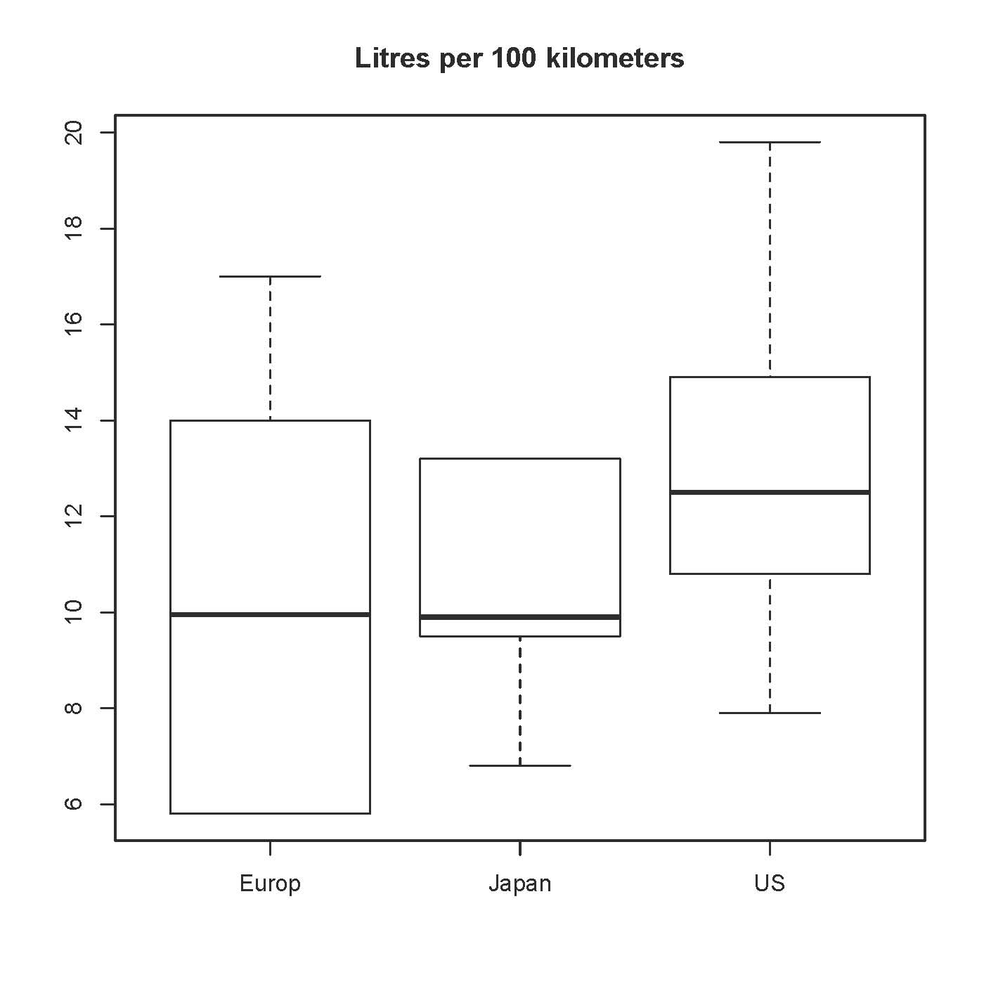

> n = length(length); n
[1] 100
> # Make indicator dummy variables for Cntry
> # U.S. will be the reference category
> c1 = numeric(n); c1[Cntry=='Europ'] = 1
> table(c1,Cntry)
Cntry
c1 Europ Japan US
0 0 13 73
1 14 0 0
> c2 = numeric(n); c2[Cntry=='Japan'] = 1
> table(c2,Cntry)
Cntry
c2 Europ Japan US
0 14 0 73
1 0 13 0
>
> # Take a look at mean fuel consumption per country
> aggregate(lper100k,by=list(Cntry),FUN=mean)
Group.1 x
1 Europ 10.17857
2 Japan 10.68462
3 US 12.96438
> # Must specify a LIST of grouping factors

On average, the U.S. cars seem to be using more fuel. Back it up with a hypothesis test.

Origin c1 c2 E(Y|X=x) = β0 + β1Χ1 + β2Χ2
Europe | 1 | 0 | β0 + β1
Japan | 0 | 1 | β0 + β2
U.S. | 0 | 0 | β0

> # One-factor ANOVA to compare means
> justcountry = lm(lper100k ~ c1+c2)
> summary(justcountry)

Call:
lm(formula = lper100k ~ c1 + c2)

Residuals:
Min 1Q Median 3Q Max
-5.0644 -2.1644 -0.4644 2.5154 6.8356

Coefficients:
Estimate Std. Error t value Pr(>|t|)
(Intercept) 12.9644 0.3651 35.511 < 2e-16 ***
c1 -2.7858 0.9101 -3.061 0.00285 **
c2 -2.2798 0.9390 -2.428 0.01703 *
---
Signif. codes: 0 ‘***’ 0.001 ‘**’ 0.01 ‘*’ 0.05 ‘.’ 0.1 ‘ ’ 1

Residual standard error: 3.119 on 97 degrees of freedom
Multiple R-squared: 0.1203, Adjusted R-squared: 0.1022
F-statistic: 6.634 on 2 and 97 DF, p-value: 0.001993

>
> # Get nicer-looking ANOVA summary table
> is.factor(Cntry)
[1] TRUE
> jc2 = aov(lper100k~Cntry); summary(jc2) # aov is a wrapper for lm
Df Sum Sq Mean Sq F value Pr(>F)
Cntry 2 129.1 64.55 6.634 0.00199 **
Residuals 97 943.8 9.73
---
Signif. codes: 0 ‘***’ 0.001 ‘**’ 0.01 ‘*’ 0.05 ‘.’ 0.1 ‘ ’ 1
>
> # Which means are different?
> TukeyHSD(jc2,ordered=T)
Tukey multiple comparisons of means
95% family-wise confidence level
factor levels have been ordered

Fit: aov(formula = lper100k ~ Cntry)

$Cntry
diff lwr upr p adj
Japan-Europ 0.506044 -2.35364917 3.365737 0.9069443
US-Europ 2.785812 0.61956789 4.952056 0.0079628
US-Japan 2.279768 0.04470727 4.514829 0.0445191

>
> # The factor Cntry has dummy vars built in.
> # What are they?
> contrasts(Cntry) # Note alphabetical order
Japan US
Europ 0 0
Japan 1 0
US 0 1
>
> summary(lm(lper100k~Cntry))

> summary(lm(lper100k~Cntry))

Call:
lm(formula = lper100k ~ Cntry)

Residuals:
Min 1Q Median 3Q Max
-5.0644 -2.1644 -0.4644 2.5154 6.8356

Coefficients:
Estimate Std. Error t value Pr(>|t|)
(Intercept) 10.1786 0.8337 12.209 < 2e-16 ***
CntryJapan 0.5060 1.2014 0.421 0.67454
CntryUS 2.7858 0.9101 3.061 0.00285 **
---
Signif. codes: 0 ‘***’ 0.001 ‘**’ 0.01 ‘*’ 0.05 ‘.’ 0.1 ‘ ’ 1

Residual standard error: 3.119 on 97 degrees of freedom
Multiple R-squared: 0.1203, Adjusted R-squared: 0.1022
F-statistic: 6.634 on 2 and 97 DF, p-value: 0.001993

> # You can select the dummy variable coding scheme.
> contr.sum(3) # Effect coding
[,1] [,2]
1 1 0
2 0 1
3 -1 -1
> contr.treatment(3,base=2) # Category 2 is the reference category
1 3
1 1 0
2 0 0
3 0 1

> # U.S. as reference category again
> Country = Cntry
> contrasts(Country) = contr.treatment(3,base=3)
> summary(lm(lper100k~Country))

Call:
lm(formula = lper100k ~ Country)

Residuals:
Min 1Q Median 3Q Max
-5.0644 -2.1644 -0.4644 2.5154 6.8356

Coefficients:
Estimate Std. Error t value Pr(>|t|)
(Intercept) 12.9644 0.3651 35.511 < 2e-16 ***
Country1 -2.7858 0.9101 -3.061 0.00285 **
Country2 -2.2798 0.9390 -2.428 0.01703 *
---
Signif. codes: 0 ‘***’ 0.001 ‘**’ 0.01 ‘*’ 0.05 ‘.’ 0.1 ‘ ’ 1

Residual standard error: 3.119 on 97 degrees of freedom
Multiple R-squared: 0.1203, Adjusted R-squared: 0.1022
F-statistic: 6.634 on 2 and 97 DF, p-value: 0.001993

Include covariates

Origin c1 c2 E(Y|X=x) = β0 + β1Ξ1 + β2Ξ2 + β3Χ1 + β4Χ2
Europe | 1 | 0 | (β0 + β3) + β1Ξ1 + β2Ξ2
Japan | 0 | 1 | (β0 + β4) + β1Ξ1 + β2Ξ2
U.S. | 0 | 0 | β0 + β1Ξ1 + β2Ξ2

> # Include covariates
> fullmodel = lm(lper100k ~ weight+length+Country)
> summary(fullmodel) # Look carefully at the signs!

Call:
lm(formula = lper100k ~ weight + length + Country)

Residuals:
Min 1Q Median 3Q Max
-4.5063 -0.8813 0.0147 1.3043 2.9432

Coefficients:
Estimate Std. Error t value Pr(>|t|)
(Intercept) -7.276937 3.006354 -2.421 0.017399 *
weight 0.005457 0.001472 3.707 0.000352 ***
length 2.345968 0.980329 2.393 0.018676 *
Country1 1.487722 0.575633 2.584 0.011274 *
Country2 1.994239 0.584995 3.409 0.000958 ***
---
Signif. codes: 0 ‘***’ 0.001 ‘**’ 0.01 ‘*’ 0.05 ‘.’ 0.1 ‘ ’ 1

Residual standard error: 1.703 on 95 degrees of freedom
Multiple R-squared: 0.7431, Adjusted R-squared: 0.7323
F-statistic: 68.71 on 4 and 95 DF, p-value: < 2.2e-16
> # Mean fuel Consumption "adjusted" for the covariates is Y-hat
> # for each country, with covariates set to overall sample mean values.
> xbar1=mean(weight); xbar2= mean(length)
> betahat = fullmodel$coefficients; betahat
(Intercept) weight length Country1 Country2
-7.276936526 0.005456609 2.345968436 1.487721833 1.994238863
> adjEurope = sum(betahat*c(1,xbar1,xbar2,1,0)); adjEurope
[1] 13.29819
> adjJapan = sum(betahat*c(1,xbar1,xbar2,0,1)); adjJapan
[1] 13.80471
> adjUS = sum(betahat*c(1,xbar1,xbar2,0,0)); adjUS
[1] 11.81047
> # Test car size controlling for country
> anova(justcountry,fullmodel) # Full vs reduced
Analysis of Variance Table

Model 1: lper100k ~ c1 + c2
Model 2: lper100k ~ weight + length + Country
Res.Df RSS Df Sum of Sq F Pr(>F)
1 97 943.81
2 95 275.61 2 668.2 115.16 < 2.2e-16 ***
---
Signif. codes: 0 ‘***’ 0.001 ‘**’ 0.01 ‘*’ 0.05 ‘.’ 0.1 ‘ ’ 1
> # I advise using anova ONLY to compare full and reduced models>
> # Test country controlling for size. It's the main question.
> justsize = lm(lper100k ~ weight+length); summary(justsize)

Call:
lm(formula = lper100k ~ weight + length)

Residuals:
Min 1Q Median 3Q Max
-4.3857 -1.0684 -0.0556 1.3077 4.0429

Coefficients:
Estimate Std. Error t value Pr(>|t|)
(Intercept) -3.617472 2.958472 -1.223 0.22439
weight 0.004949 0.001546 3.202 0.00185 **
length 1.835625 1.017349 1.804 0.07428 .
---
Signif. codes: 0 ‘***’ 0.001 ‘**’ 0.01 ‘*’ 0.05 ‘.’ 0.1 ‘ ’ 1

Residual standard error: 1.804 on 97 degrees of freedom
Multiple R-squared: 0.7058, Adjusted R-squared: 0.6997
F-statistic: 116.4 on 2 and 97 DF, p-value: < 2.2e-16

> anova(justsize,fullmodel)
Analysis of Variance Table

Model 1: lper100k ~ weight + length
Model 2: lper100k ~ weight + length + Country
Res.Df RSS Df Sum of Sq F Pr(>F)
1 97 315.64
2 95 275.61 2 40.035 6.8999 0.001592 **
---
Signif. codes: 0 ‘***’ 0.001 ‘**’ 0.01 ‘*’ 0.05 ‘.’ 0.1 ‘ ’ 1
> # How strong is the relationship? Proportion of remaining variation.

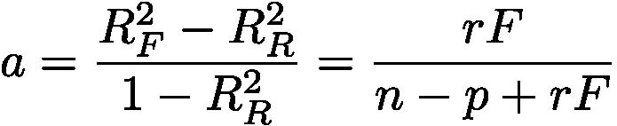
> # R^2 for full model is 0.7431 and R^2 for reduced model is 0.7058
> (0.7431-0.7058)/(1-0.7058)
[1] 0.1267845
> # Or equivalently,
> anova(justsize,fullmodel) # Repeating
Analysis of Variance Table

Model 1: lper100k ~ weight + length
Model 2: lper100k ~ weight + length + Country
Res.Df RSS Df Sum of Sq F Pr(>F)
1 97 315.64
2 95 275.61 2 40.035 6.8999 0.001592 **
---
Signif. codes: 0 ‘***’ 0.001 ‘**’ 0.01 ‘*’ 0.05 ‘.’ 0.1 ‘ ’ 1
> 2*6.8999/(95+2*6.8999)
[1] 0.1268366

> # How about confidence intervals? Based on output from full model,

Coefficients:
Estimate Std. Error t value Pr(>|t|)
(Intercept) -3.617472 2.958472 -1.223 0.22439
weight 0.004949 0.001546 3.202 0.00185 **
length 1.835625 1.017349 1.804 0.07428 .

>
> critval = qt(0.975,95)
> # Margin of error is critical value times standard error
> me1 = critval*0.575633; me2 = critval*0.584995
> # Europe vs US
> LO1 = betahat[4]-me1; HI1 = betahat[4]+me1; cbind(LO1, HI1)
LO1 HI1
Country1 0.3449458 2.630498
> # Japan vs US
> LO2 = betahat[5]-me2; HI2 = betahat[5]+me2; cbind(LO2, HI2)
LO2 HI2
Country2 0.832877 3.155601
>
> # General linear test: Compare F = 6.8999

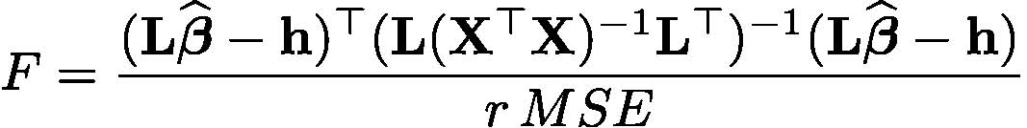
> # First do it the hard way
> fullmod = lm(lper100k ~ weight+length+Country,x=T) # To get X matrix, x=T
> L = rbind(c(0,0,0,1,0),
+ c(0,0,0,0,1))
> r = dim(L)[1]
> X = fullmod$x
> xtxinv = solve(t(X)%*%X)
> MSE = deviance(fullmod)/df.residual(fullmod) # MSE = SSE/(n-p)
> Fstat = ( t(L%*%betahat) %*% solve(L%*%xtxinv%*%t(L)) %*% L%*%betahat ) / (r*MSE)
> Fstat = as.numeric(Fstat); Fstat
[1] 6.89995

> # The easy way
> source("http://www.utstat.utoronto.ca/~brunner/Rfunctions/ftest.txt")
> ftest # See function definition
function(model,L,h=0)
# General linear test of H0: L beta = h
{
BetaHat = model$coefficients
dimL = dim(L)
if(length(BetaHat) != dimL[2]) stop("Sizes of L and Beta are incompatible")
r = dimL[1]
if(qr(L)$rank != r) stop("Rows of L must be linearly independent.")
out = numeric(4)
names(out) = c("F","df1","df2","p-value")
dfe = df.residual(model)
diff = L%*%BetaHat-h
fstat = t(diff) %*% solve(L%*%vcov(model)%*%t(L)) %*% diff / r
# Note vcov = MSE * XtXinv
fstat = as.numeric(fstat)
out[1] = fstat; out[2]=r; out[3]=dfe
out[4] = 1-pf(fstat,r,dfe)
return(out)
}
> ftest(fullmodel,LL) # Again compare F = 6.8999 from full-reduced
F df1 df2 p-value
6.899949667 2.000000000 95.000000000 0.001592274

> ###### Predictions and prediction intervals ######
>
> # Predict litres per 100 km for a Japanese car weighing 1295kg, 4.52m long
> # (1990 Toyota Camry)
> betahat = fullmodel$coefficients; betahat
(Intercept) weight length Country1 Country2
-7.276936526 0.005456609 2.345968436 1.487721833 1.994238863
> contrasts(Country)
1 2
Europ 1 0
Japan 0 1
US 0 0
> x1 = c(1,1295,4.52,0,1)
> sum(x1*betahat)
[1] 12.38739
>
> # Use the predict function
> # help(predict.lm)
>
> camry1990 = data.frame(weight=1295,length=4.52,Country='Japan'); camry1990
weight length Country
1 1295 4.52 Japan
> predict(fullmodel,newdata=camry1990)
1
12.38739
> # With 95 percent prediction interval (default)
> predict(fullmodel,newdata=camry1990, interval='prediction')
fit lwr upr
1 12.38739 8.856608 15.91817

>
> # Multiple predictions
> cadillac1990 = data.frame(weight=1800,length=5.22,Country='US')
> volvo1990 = data.frame(weight=1371,length=4.823,Country='Europ')
> newcars = rbind(camry1990,cadillac1990,volvo1990); newcars
weight length Country
1 1295 4.520 Japan
2 1800 5.220 US
3 1371 4.823 Europ
> is.data.frame(newcars)
[1] TRUE
> predict(fullmodel,newdata=newcars, interval='prediction')
fit lwr upr
1 12.38739 8.856608 15.91817
2 14.79091 11.354379 18.22745
3 13.00640 9.481598 16.53121
>
> # It's not a bad idea to "predict" the observed data
> # Just look at the first 10 rows, for example
> cbind(lper100k,predict(fullmodel,interval='prediction'))[1:10,]
lper100k fit lwr upr
1 19.8 18.495691 15.012790 21.97859
2 9.9 10.450367 6.940724 13.96001
3 10.8 9.222800 5.747978 12.69762
4 12.5 12.590305 9.162660 16.01795
5 12.5 12.626349 9.219284 16.03341
6 12.5 12.626349 9.219284 16.03341
7 10.4 9.766491 6.236956 13.29603
8 13.2 14.570386 11.135730 18.00504
9 17.0 14.056832 10.515850 17.59782
10 9.2 8.330626 4.870298 11.79095
Warning message:
In predict.lm(fullmodel, interval = "prediction") :
Predictions on current data refer to _future_ responses

This handout was prepared by Jerry Brunner, Department of Statistical Sciences, University of Toronto. It is licensed under a Creative Commons Attribution - ShareAlike 3.0 Unported License. Use any part of it as you like and share the result freely. The OpenOffice.org document is available from the course website:

http://www.utstat.toronto.edu/~brunner/oldclass/2101f19

* Copyright information is on the last page.

